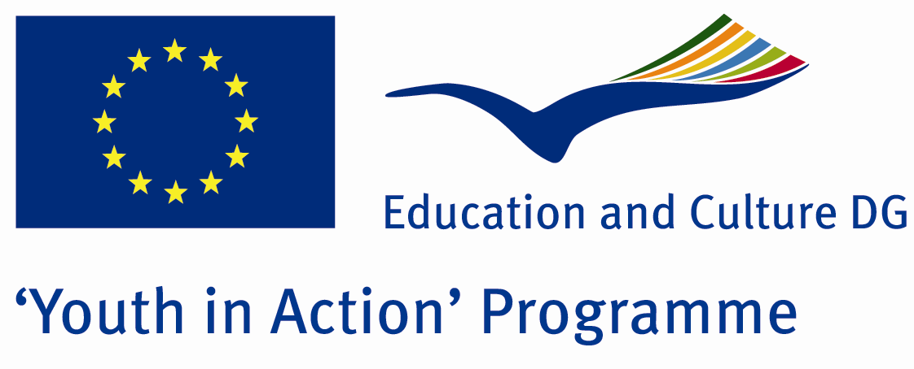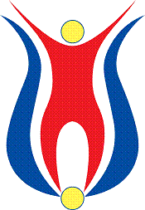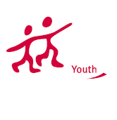

Action 4.3
Project Summary; Chernobyl first, then Fukishima. What next? Radioactive leak mixing the free air, from these accident sites, destroyed the nature, caused many people suffer injuries and sickness. Their effects are still going on, although the decades passed since then. Isn’t it the time to stop that danger, don’t you think?

Project Title; ATTENTION; RADIOCTIVE LEAKAGE

Date and Venue ; 09/16 August 2012
Place: Sinop, Turkey.

Target Group ; Municipalities, City Councils and Non-Governmental organizations,
youth groups,culture and art groups,e.t.c

Participants ; 5 people from each country (over 18 -25 ). Totally 8 countries.

Conditions ; Accommodation, board and programme costs will be financed through European Commission Youth in Action Programme . Travel costs will be reimbursed in 70% (APEX Tarrifs). Organizations from all 27 EU member countries plus Liechtenstein , Norway and Iceland are eligible to take part.

Working language: English

Organisator group:Group Zeus

How to apply: If you are interested, please send your Part III forms to
by e-mail please (in word file). Scan Part3 format is enough for application.(Fulfilled Part III which you can find in the attachment, of course signed and stamped) ..

Contact e-mail: groupzeusgroupzeus@gmail.com

